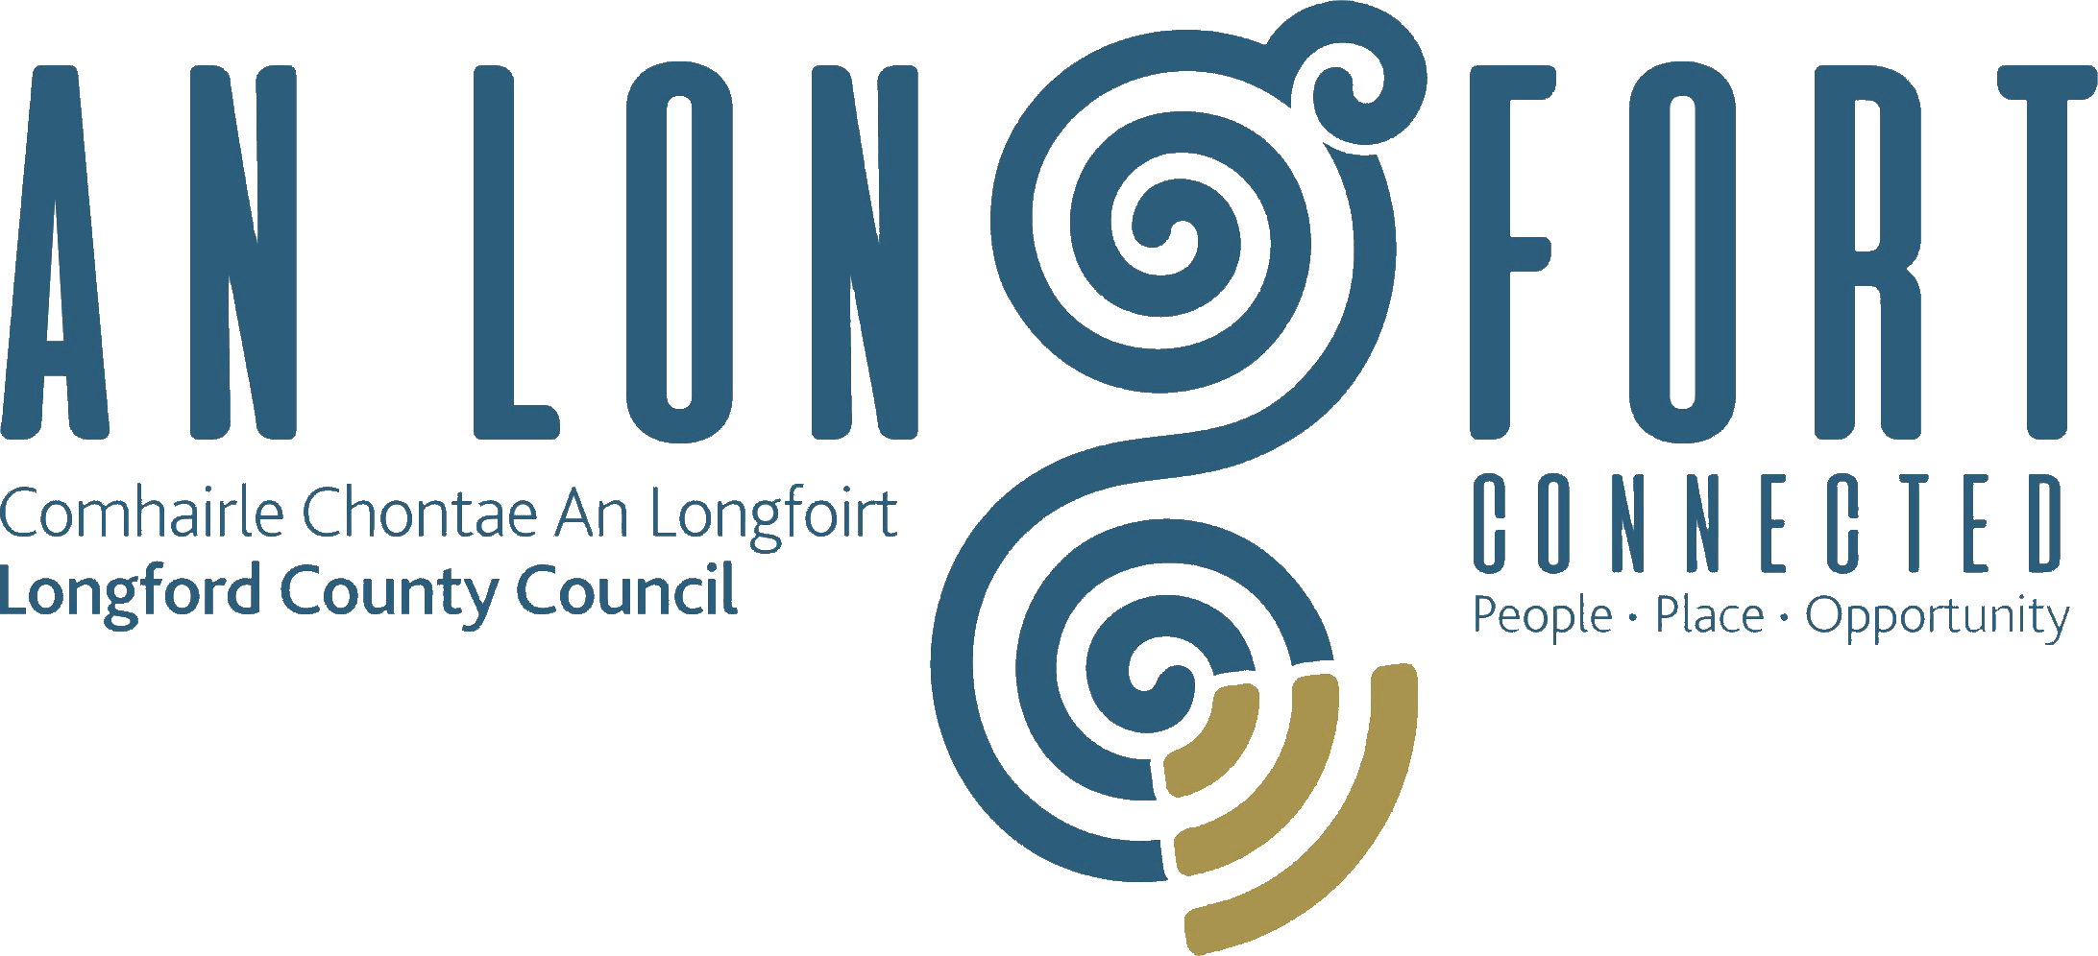

Minutes of Monthly Meeting of Longford County Council
held in the Council Chamber, Aras an Chontae, Great Water Street, Longford on
Wednesday, 11th April 2018 at 3.30 p.m.
_____________________________________________________________________

PRESIDING: Councillor Martin Mulleady, Cathaoirleach.

MEMBERS PRESENT: Councillors – Paraic Brady, John Browne, Seamus Butler, Mick Cahill, Micheál Carrigy, Mark Casey, Gerard Farrell, Joe Flaherty, Gerard Hagan, Luie McEntire, Colm Murray, Peggy Nolan, Pat O’Toole, P.J. Reilly, Paul Ross, Mae Sexton and Gerry Warnock.

IN ATTENDANCE: Mr. Paddy Mahon, Chief Executive.
Mr. John McKeon, Head of Finance.
Ms. Barbara Heslin, Director of Services.
Mr. John Brannigan, Director of Services.

MEETINGS
ADMINISTRATOR: Ms. Anne Lee.

ATTENDANCE OF BARRY KENNY FROM IARNROD EIREANN.

Barry Kenny, Corporate Communications Manager with Iarnrod Eireann addressed the members on the following issues and replied to queries raised -

- Route Distance.
- Services - Dublin to Longford, Longford to Sligo.
- Journey Times.
- Route Passenger Numbers.
- Typical Daily Journeys to/from Longford.
- Punctuality.
- Demand Growth.
- Capacity Issues.
- Anti-social behaviour on Trains.
- Customer Service.
- Higher Speed Network.

Longford Station -
- Current/Recent Works.
- Upcoming Works.

ADOPTION OF MINUTES.

On the proposal of Councillor C. Murray seconded by Councillor Councillor P. O’Toole, the Minutes of Monthly Meeting of Longford County Council held on the 14th March 2018, as circulated, were confirmed and adopted.

Irish Immigrant Council.

The Cathaoirleach welcomed Uruemu (Remu) Adejinmi. Originally from Nigeria, Remu has commenced an internship with the Irish Immigrant Council and will closely follow the workings of local government in the county for a number of months. She is one of nine people taking part in the programme nationwide with a view to creating greater awareness of, and participation in local government, by the new Irish communities.

MATTERS ARISING FROM MINUTES.

Twinning with Baltimore, US.

Councillor M. Carrigy stated that he still considers that there will be advantages in entering into a twinning arrangement with Baltimore and did not agree with the sentiments expressed by Councillor Joe Flaherty at the March meeting of the Council.

FILLING OF VACANCY OCCASIONED BY THE RESIGNATION OF
COUNCILLOR JOHN DUFFY.

A. Lee, Meetings Administrator, read the following correspondence to the meeting:-

(a) Letter dated 3rd April 2018 received from Mr. Gerard Hagan stating that in accordance with the provisions of Section 19(3) of the Local Government Act 2001, he has given consent to his nomination by the Fine Gael party as co-optee to Longford County Council to fill the casual vacancy created by the resignation of Councillor John Duffy.
(b) Letter dated 3rd April 2018 received from Mr. Tom Curran, Fine Gael General Secretary notifying Longford County Council that in order to comply with S.19(3) of the Local Government Act 2001, the Fine Gael Party have selected
Mr. Gerard Hagan to fill the casual vacancy on Longford County Council created by the resignation of Councillor John Duffy.

Councillor M. Carrigy proposed and Councillor P. Brady seconded that
Mr. Gerard Hagan be elected to the vacancy for the Granard Electoral Area, occasioned by the resignation of Councillor John Duffy.

The Cathaoirleach, Councillor Martin Mulleady, invited Councillor Hagan to join the meeting of the Council.

The Members welcomed Councillor Hagan onto Longford County Council and wished him every success.

Councillor Hagan thanked his proposer and seconder and the Fine Gael party for his nomination to replace John Duffy. He complimented John Duffy for his outstanding work while a member of Longford County Council and stated it is a great honour for him and his family to be co-opted to the Council to replace John. Councillor Hagan stated that he will endeavour to give his best to the Council. Councillor Hagan also acknowledged the presence of the media at the Council Meeting.

The Chief Executive, on his own behalf and on behalf of the staff of the Council, welcomed Councillor Hagan to the Council and assured him of the assistance and support of the staff.

MEMBERSHIP OF INFRASTRUCTURE AND ENVIRONMENT STRATEGIC POLICY COMMITTEE.

Consequent on the resignation of Councillor John Duffy, Councillor Gerard Hagan was appointed to the Infrastructure and Environment Strategic Policy Committee.

VOTES OF SYMPATHY.

Councillor M. Carrigy proposed and Councillor P. Brady seconded that a vote of sympathy be extended to the Josephine McGuinness and family, Cahanagh, Longford on the death of
Pat McGuinness.

Councillor M. Carrigy proposed and Councillor P. Brady seconded that a vote of sympathy be extended to the Bissett family, Fostra, Aughnacliffe on the death of Rebecca Bissett.

Councillor M. Carrigy proposed and Councillor P. Brady seconded that a vote of sympathy be extended to the Dolores McGuinness and family, Cahanagh, Longford on the death of Peter McGovern, Ballinulty, Dring.

Councillor M. Carrigy proposed and Councillor P. Brady seconded that a vote of sympathy be extended to the Healy family, Fardromin, Ballinamuck on the death of Alice Healy.

CHIEF EXECUTIVE ORDERS.

The Chief Executive Orders, as circulated, were noted.

MONTHLY MANAGEMENT REPORT.

The Monthly Management Report, as circulated, was noted.

New Bridge over the River Camlin.

In response to a query from Councillor M. Sexton, B. Heslin confirmed that there are no agreed or final plans regarding the site adjacent to the new bridge. In the interim, the site has been tidied up and a new footpath provided.

Councillor P. Nolan referred to the decision taken by Longford Municipal District to provide lighting on the three bridges

CORPORATE POLICY GROUP MINUTES.

The adopted Minutes of Corporate Policy Group Meeting held on the
14th February 2018, as circulated, were noted.

ECONOMIC AND COMMUNITY DEVELOPMENT, PLANNING, HUMAN RESOURCES & CORPORATE SERVICES, CULTURAL & RECREATIONAL SERVICES.

Planning Applications.

The list of Planning Applications received since the last meeting of the Council was submitted and noted.

Draft Annual Report 2017

On the proposal of Councillor S. Butler seconded by Councillor P. Nolan, it was unanimously agreed to adopt the Draft Annual Report 2017 prepared in accordance with Section 21 of Local Government Act 2001, as circulated.

B. Heslin stated that the 2017 Performance Indicators will be included in the final
2017 Annual Report which will be presented to the members in June.

2018 CLAR Programme

B. Heslin briefed the members regarding the 2018 CLAR Programme, as circulated.

She stated that Longford County Council in conjunction with the Department of Rural and Community Development invites schools, community groups and local development companies to apply for funding under the CLÁR Programme 2018.
- Measure 1: Support for Schools/Community Safety Measures
- Measure 2: Schools/Community Play areas

Application forms and details are available at: CLÁR 2018 Programme or from Longford County Council, Aras an Chontae, Great Water Street, Longford, telephone (043) 3343313/3343472 email commgrants@longfordcoco.ie

The closing date for receipt of completed application forms is Friday 20th April 2018 at 5pm and this will be strictly enforced. Application forms and details are also available under Measure 3- First Response Support Measures- from established organisations that operate entirely on a voluntary basis and are involved in emergency rescue/first response efforts. These application forms must be submitted directly to the Department of Rural and Community Development.

Barbara emphasised the need for the members to communicate these details to their communities.

Creative Ireland Culture and Creativity Draft Plan.

B. Heslin briefed the members on the Creative Ireland Culture and Creativity Draft Plan and complimented the Culture Team for their work on developing this ambitious Strategy.

On the proposal of Councillor P. Nolan seconded by Councillor M. Sexton, it was unanimously agreed to adopt the Creative Ireland Culture and Creativity Draft Plan, as circulated.

A formal launch of the Plan to be held at a future date.

Councillor P. Nolan proposed that funding from Central Reserves be made available for signage on the routes into Longford to celebrate Longford's wealth of culture, creativity and heritage. She also proposed that funding be provided to erect poles which could be used by various groups to promote events and festivals in the main towns. This was agreed by the members, subject to costings.

Music Generation
The members welcomed the Government’s decision to make the Music Generation Programme available to all children and acknowledged that the ETB will have an important role to play in rolling out the programme.

Request for Civic Reception - 7th International Farrell Clan Rally - 16th July 2018.

On the proposal of Councillor P. Nolan seconded by Councillor M. Sexton, it was unanimously agreed that a Civic Reception be held on the 16th July 2018 in honour of the
7th International Farrell Clan Rally.

Nomination of One Member to Longford Local Community Development Committee.

Councillor S. Butler proposed and Councillor L. McEntire seconded that
Councillor Joe Flaherty be nominated to the Longford Local Community Development Committee, to replace Councillor Gerry Warnock.

SUPPLEMENT TO REGISTER OF ELECTORS.

Referendum - Thirty-Six Amendment of The Constitution Bill 2018

B. Heslin informed the members that the closing date for receipt of applications for inclusion on the Supplement to the Register is Tuesday 8th May 2018 and the closing date for the supplement to the postal and specials voters list is Saturday 28th April 2018.

HOUSING, INFRASTRUCTURE, ENVIRONMENT & EMERGENCY SERVICES.

Disposal of Freehold Interest of Property at No. 9, Chapel Street, Longford.

On the proposal of Councillor S. Butler seconded by Councillor P. Nolan, it was unanimously agreed to the disposal of Freehold Interest of Property at No. 9, Chapel Street, Longford to Patrick Ryan in accordance with the terms of Section 183 of the Local Government Act 2001 issued on the 9th March 2018.

FINANCE & INFORMATION SYSTEMS.

Public Liability Claims.

It was noted that three Public Liability Claims were received during March 2018.

Update on National Broadband Plan.

Christine Collins, Broadband Officer, gave a comprehensive update on the National Broadband Plan including details on the following –

- Open eir 300k rural fibre to the home.
- The National Broadband Interactive Map
- Proposal of a telecoms/broadband connection
- Mobile Voice Black Spot Identification Survey
- Digital Strategy

Disposal of LEDCO Building, Ballinalee Road, Longford

On the proposal of Councillor Seamus Butler seconded by Councillor Peggy Nolan, it was unanimously agreed to dispose of LEDCO Building, Ballinalee Road, Longford to Gingerhill Ltd., One Spencer Dock, North Wall Quay, Dublin 1 in accordance with the terms of Section 183 of the Local Government Act 2001 issued on the 26th March 2017, subject to the following conditions -

- That Longford County Council does everything within its powers to cater for the vacant possession timeline requests of the purchaser, while not affecting the on-going viability of the Individual Leaseholders.
- That the site reverts to Longford County Council, for equivalent consideration, in the event that it is not used for its intended purpose within three years of contracts being signed.

Refurbishment of Council Chamber.

On the proposal of Councillor M. Cahill seconded by Councillor P. Nolan, it was unanimously agreed that there is need for the Council Chamber to be extended and refurbished.

J. McKeon stated that works on the Council Chamber are being considered as part of the ergonomics survey which is currently being undertaken.
GENERAL.

Notices of Motions.

Trafficking of Human Organs.

The following Notice of Motion was proposed by Councillor P. Nolan and seconded by Councillor P. Brady -

“That this Council calls on the Irish Government to ratify, as soon as possible, the Convention against trafficking in human organs, which was adopted by the Council of Europe on 9 July 2014 in order to criminalise illegal organ transplantations. The Irish Government has already signed this convention, but yet to ratify it.”

Councillor Nolan received the support of the members. An email to be forwarded to the Office of An Taoiseach.

Private Pensions.

The following Notice of Motion was proposed by Councillor M. Carrigy and seconded by Councillor P. Nolan -

“I call on the Government to introduce legislation to protect private pensions in the future. Private pensions are not a luxury but rather the savings of hard working individuals who have saved so they can look after themselves when they retire rather than rely solely on
the State.”

Councillor Carrigy received the support of the members. An email to be forwarded to the Office of An Taoiseach.

Ombudsman for People with Disabilities.”

The following Notice of Motion was proposed by Councillor M. Carrigy and seconded by Councillor P. Nolan -

“I call on the Minister of State, Finian McGrath, to appoint an Ombudsman for People with
Disabilities.”

Councillor Carrigy received the support of the members. An email to be forwarded to Minister McGrath.

Correspondence – circulated.

Correspondence dated 28th March 2018 received from Deputy Willie Penrose and correspondence dated 29th March 2018 received from the Office of the Minister for Children and Youth Affairs regarding Family Resource Centre for Longford town was noted.
Councillor Sexton expressed disappointment with replies received and confirmed that she will continue to pursue this issue.

Correspondence dated 29th March 2018 received from Minister Shane Ross in relation to the proposed Lakelands Brand was noted.

Correspondence dated 21st March 2018 received from “See Change” regarding the 6th Annual Green Ribbon Campaign and “Light Up Green” Campaign was noted.

Fodder Crisis.

On the proposal of Councillor M. Mulleady seconded by Councillor L. McEntire, it was unanimously agreed that the Minister for Agriculture be requested to receive a deputation from Longford County Council regarding the Fodder Crisis.

This concluded the business of the meeting.
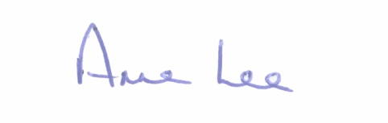

Signed: _______________
Anne Lee,
Meetings Administrator.

Confirmed and adopted at Monthly Meeting of Longford County Council held on the
9th May 2018.

Signed: _______________
Cathaoirleach.

